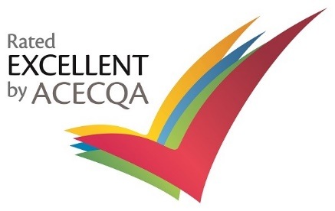

August Newsletter

Staffing Update

The staff for Term 3, 2022 include:
- Anne Whittleston (Director / Teacher)

- Jen Reid (Assistant Director / Educator)

- Nathan McGuinness (Community Development Coordinator)

- Tamara Hall (Speech Pathologist)

- Sarah Harry (Occupational Therapist)

- Michelle Cullen (Teacher)

- Roshni Amroliwala (Teacher)

- Lisa Edwards (Teacher)

- Amanda Smith (Educator)

- Magdaline Saredakis (Educator)

- Adrienne Hicks (Educator)

- Noella Saad (Educator)

- Lisa Mildrum (Educator)

- Jodie Murray (Educator / WH&S)

- Andrea Randell (Educator)

- Le-arna Rathjen (Educator)

- Julia Tilley (Educator)

- Iona Angely (Educator)

- Rinjani Bonavidi (Educator)

- Jess Maher (Educator)

- Lisa Chalmers (Educator)

- Nobuko Nakajima (Educator)

- Mayuko Mulholland (Cook/ Educator)

- Yogini Patel (Educator)

- Kelly McDonald (Educator)

- Zhara (Educator)

- Cathy Mazzarolo (Admin Officer)

- Kylie Webster (Finance Officer)

- Jo Oliver (Cook / Educator)

- Simon Costello (Groundsperson)
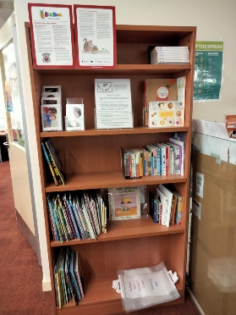
Children’s Library

Did you know that we have a Children’s Library that you can borrow many of our wonderful books?
You are welcome to peruse through the library with your child to choose a book, sign it out and then take it home to read, returning it once you have finished.
There are books for children of all ages up to school age.
Some of the benefits to reading to your child include
- Bonding, - providing a wonderful opportunity for you and your child to connect. It’s a nice way to spend time together and slow down during an otherwise hectic day
- Listening skills - Hearing a story read aloud involves some level of comprehension on your child’s part.
- Cognitive and Language skills - Even the youngest children benefit from hearing their caregivers read to them. Studies have shown that babies who are read to and talked to score higher in language skills and cognitive / intellectual development.

Curriculum
Our Book based program this term will focus on Tiddalick – The frog who caused a flood.

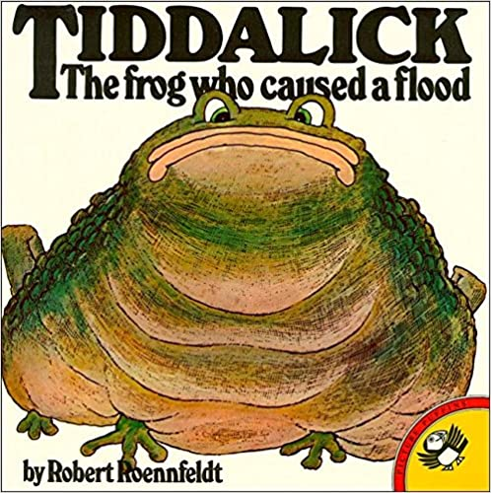

This is An Aboriginal dreaming story based upon natural history facts. The giant frog, Tiddalick, drank all the water in the world and the only way to stop the ensuing drought was to make him laugh and spill the water. However, all the animals cannot raise a giggle.

The Tiddalick story helps to teach children a number of different lessons: The importance of our environment and the preciousness of our water resources. The value of our Elders and the importance of listening to those whose life experiences can help us make good decisions. To share and not be greedy or selfish.
We are delighted to announce that Aboriginal Artists from Marra Dreaming will visit our Centre over a period of 4 days to work with our children as part of a cultural awareness program.

Marra Dreaming is a cultural community centre located in the Northern suburbs of Adelaide. It was established in 1999 by predominately Aboriginal women from various regions of Australia. It was initially set up to provide a space for Aboriginal people to develop their artwork and is now a thriving meeting place for community to experience and explore the Aboriginal culture.

A series of wall murals will be developed by our children in consultation with the Artists from Marra Dreaming which we plan to prominently display on the front exterior of our building.

2023 Preschool Program

On 29 July 2022 letters will be sent to families who have registered an Expression of Interest in our Preschool Program and who live in our immediate catchment area
- Bridge Road
- McIntyre Road
- The Golden Way
- The Grove Way
offering a place in our Preschool Program for 2023.

Depending on the number of available positions, offers for families who live beyond the catchment will be mailed out approximately 4 weeks later.

The aim of this procedure is to ensure that children are offered a place in their local centre. A consistent state-wide approach, including the establishment of local catchment areas, ensures that all families are provided with the same information about their Preschool enrolment options.

Preschool Pupil Free Day

Governing Council have approved a Pupil Free Day for Monday 5 September. This is a mutual pupil free day across the partnership.
Our core Educators from across our site will spend the day monitoring the progress of our Prior to School Quality Improvement Plans (PQIP’s) and reviewing Policies and Procedures.
Long Day Care will be available to families who have children with a regular LDC booking each Monday.
Please confirm with Cathy if you need this service on Monday 5 September.

Photo Day

Individual photos of children who attend our Centre will be taken by a professional photographer on
Monday 29 August and
Friday 2 September.
More information including a booking form will be available very soon.

If your child does not attend on either of these days you could make a booking to come in early in the morning with your child to have their photo taken and then take your child home.

Health Checks

As part of a range of services to children and families in South Australia, the State Government provides funding to Child and Youth Health to offer free health assessments for Preschool children.
A CYH Nurse will provide assessments on

Thursday 22 September 2022
Unfortunately due to ongoing Covid restrictions, there are only 8 appointment times available.
If your child is 4 years and 3 months or older please collect a consent form from our front office.
Bookings essential.

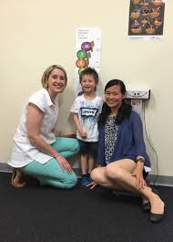

Term 3 Dates

The Preschool program will close for 2 weeks from Monday 3 October (public Holiday) to Friday 14 October – inclusive.
Preschool will resume Monday 17 October for Term 4.

Our Long Day Care program will remain open (apart from the Public Holiday).
If your Preschool child requires care during these holidays PLEASE check with Cathy (front office) as we have limited availability during this time.

Reminder – Whole Site End of Year Closure

Governing Council approved to close the whole Centre from 12.30pm on Friday 16 December 2022 @ 12.30pm.
The Long Day Care program will then resume on
Monday 9 January 2023.

Community Development Update

Circle of Security:
Sarah (Occupational Therapist) will run Circle of Security for 8 weeks on a Tuesday morning from 9:30-11:30.
We have a capacity of 8 participants.

The Circle of Security Parenting™ program is based on evidence based research about how secure parent-child relationships can be supported and strengthened.
Learning Objectives:
• Understand your child’s emotional world by learning to read their emotional needs.
• Support your child’s ability to successfully manage emotions.
• Enhance the development of your child's self-esteem.
• Honor your innate wisdom and desire for your child to be secure.

Being with Baby: This group is almost at capacity due to the popularity of the program. We have moved the day and time of the program to Wednesday afternoons form 1pm until 2:30pm. This 7-week program will begin on the 10th of August.

Infant Massage: Is scheduled to start Friday 29 July. Due to overwhelming demand we are now offering this program every term. This program will continue to run on Friday mornings from 10am until 11:30am.

Wiggle & Giggle: Is a new program being offered at KFCC. Mel (who is the facilitator for Infant Massage) is also the facilitator of Wiggle and Giggle.
This is a 5-week program, which is an interactive music and movement program. Children get to explore their world through a combination of dance, music, percussion, creative role play and relaxation. This program is more suited to children aged 3-5 years old and will commence Friday 2 September.

Community Services use of rooms:
KFCC and ‘Blended Therapy’ have been able to form a partnership in which they will be using the Community Space and a consulting room every Thursday for term 3 to work with families within their program. Blended Therapy is an NDIS early intervention provider that aims to empower families through strong relationships to develop their confidence to support child’s development in order to thrive day to day.

Did you know that you can find Keithcot Farm Children’s Centre on Facebook?
If you like the page, you can stay up to date with community programs, as well as other relevant parenting topics.

https://www.facebook.com/keithcotfarmchildrenscentre

Please contact Nathan (CDC) for more information
- in person at the Centre
- by phone 0435 219 942
- Email: Nathan.mcguinness3@sa.gov.au

