

**KEITHCOT FARM**

***February Newsletter***

***The staff for Term 1, 2023 include***

* **Anne Whittleston** (Director / Teacher)
* **Jen Reid** (Assistant Director / Educator)
* **Nathan McGuinness** (Community Development Coordinator)
* **Louise O’Reilly** (Speech Pathologist)
* **Sarah Harry** (Occupational Therapist)
* **Roshni** **Amroliwala** (Early Childhood Teacher)
* **Zuzana Haladej** (Early Childhood Teacher)
* **Magdaline Saredakis** (Educator)
* **Adrienne Hicks** (Educator)
* **Amanda Smith** (Early Childhood Teacher)
* **Noella Saad** (Educator)
* **Lisa Mildrum** (Educator)
* **Jodie Murray** (Educator)
* **Andrea Randell** (Educator)
* **Julia Tilley** (Educator)
* **Iona Angely** (Educator)
* **Rinjani Bonavidi** (Educator)
* **Jess Maher** (Educator)
* **Lisa Chalmers** (Educator)
* **Yogini Patel** (Educator)
* **Kelly McDonald** (Educator)
* **Cathy Mazzarolo** (Admin Officer)
* **Kylie Webster** (Finance Officer)
* **Jo Oliver** (Cook / Educator)
* **Nobuko Nakajima** (Educator)
* **Mayuko Mulholland** (Kitchen support/ Educator)
* **Zahra** (Educator)

***A warm welcome to families who are new to our Centre***

***and welcome back to our existing families.***

###### Welcome to Zuzana our new Early Childhood Teacher

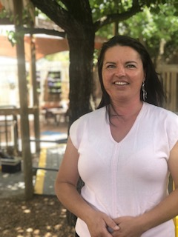

My name is Zuzana Haladej and I am a qualified early childhood teacher with a Bachelor Degree in Early Childhood Education from University of South Australia. I am also a mum to two grown up children, a 22-year-old daughter Amy and 17-year-old son Lucas. I am most excited to be joining your community and working alongside Roshni Amroliwala as well as the whole team at Keithcot Farm Children’s Centre.

My experience includes seven years in Montessori Manor Preschool and two years in Sir Thomas Playford Kindergarten. Early childhood education is my passion. I believe in the individuality of each child and that learning begins with children’s families. Therefore, I aim to create relationships with families to work in collaboration to support each individual child, their wellbeing, self-esteem and learning.

I am very excited to have the opportunity to support your children. I am looking forward to getting to know you all.

###### Welcome to Louise our new Speech Pathologist



Hello, my name is Louise! I am a speech pathologist, musician and mother of two (3yrs and 1yr). I have spent my speech pathology career working in rural South Australia in The Limestone Coast. While living in the Limestone Coast, I had the opportunity to support children and adults with communication and swallowing needs, alongside their families and carers. I thoroughly enjoyed immersing myself in the local community, performing in my band, attending local events and becoming a ‘regular’ at the best coffee shop. I have a passion for early intervention and supporting families and young children to connect through play and communicate. I have a deep appreciation for music and its role in encouraging connection, social skills, communication and wellbeing. I also have experience supporting young children develop their eating and drinking skills and supporting families to create positive mealtime environments. I am looking forward to joining your community at Keithcot Farm Children’s Centre!

**Welcome Morning Tea**



Nathan McGuinness (Community Development Coordinator) has organised a morning tea from 8.30am each morning during the first week of the school Term in our Community Space for existing and new families. Please drop in for Coffee and Chat and stay as long as you want!

Nathan develops a timetable of programs in collaboration with our multidisciplinary team.

The programs are selected in response to the needs and interests of families and parents so feel free to email or ring Nathan with your ideas or something in particular you’re looking for.

**ATTENDANCE**

The Department for Education (DfE) Enrolment policy states that Preschool children are entitled to 15 hours preschool / week for one year prior to commencing school.

**Arriving at 8.30am** gives children time to organise their belongings; choose an activity and connect with their peers before the little bells ring to signal time to come inside for a structured group time.

***This half hour (8.30 to 9.00am) is extremely important for your child – PLEASE make every effort to arrive @ 8.30am***

Our Long Day Care Program offers a minimum of 2 days/ week and a maximum of 3 days/ week.

***Please ensure your child’s regular attendance!***

***Please phone us and let us know if your child is not attending for the day. Phone: 82512700***

**Please note:** It is a National Quality Standard (NQS) regulatory requirement that children are signed in and signed out when both arriving and departing each day.

***Please ensure that all children are accompanied by an adult before opening the gates- if a child is observed to be leaving on their own, please accompany them back to a staff member!!***

The Children’s Centre is open from **7am** via the Northern Entrance for children booked into Child Care.

The main entrance is opened at 8:30am for all programs including Preschool, Long Day Care and Community Programs.

The Department for Education Preschool session times are:

8.30 - 11.30 (morning session) and

12.15–3.15 (afternoon session).

For children new to our Centre, or who have not attended for some time, we ask parents/ caregivers to please show their child where the toilets and hand washing facilities are located and where and how to get a drink of water.

For safety reasons it is imperative that the Educators are aware of who is going to be collecting your child from the Centre. If for some reason you are unable to make it to the Children’s Centre yourself and have arranged for someone else to collect your child - **please write their name in the Comments section of the sign-in sheets and notify a staff member and /or please ring the Centre and notify the staff of these changes.**

This person will be asked to provide proof of their identity (eg driver’s license) – if they are new to the Centre.

Please also note that it is **not** appropriate to send siblings into the building while you wait in the car.

###### Stay and Play

On **Wednesday 22 February from 6 to 7pm** we will have a twilight session of integrated childcare and preschool. The purpose of this informal event is for you to spend time with your child in our play-based environment and to meet some of our multidisciplinary staff team!

###### Curriculum

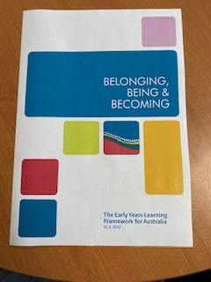

The **Early Years Learning Framework** (EYLF) describes the principles, practice, and outcomes essential to support and enhance young children’s learning from birth to five years of age, as well as their transition to school.

The Framework has a strong emphasis on play-based learning. Play is the best vehicle for young children’s learning providing the most appropriate stimulus for brain development. Through play the Framework recognises the importance of communication and language (including early literacy and numeracy) and social and emotional development.

Throughout the year our multi-disciplinary team engage in a range of training and development which keeps us up to date with local and international research. “*There is now an impressive body of evidence from a wide range of sources, demonstrating that early childhood development affects health, well-being, and competence across the balance of the life course. Quality interactions during the earliest stages of life play a crucial role in shaping children’s perceptual, cognitive and linguistic ability, their physical, social and emotional development and physical and mental health, activity, skills and behaviour in adult life.*” Moore and Australian Research Alliance for Children and Youth.

To enable our Multidisciplinary team to meet for ongoing Professional Development, the Department for Education grant permission to close the Preschool program for 4 days through the year.

Please note – there will be no Preschool on

* Thursday 6 April 2023.
* Friday 9 June 2023
* Monday 4 September 2023
* Monday 13 November 2023

Long Day Care will still be available on these days for children who have a regular LDC booking.

We have an Improvement Goal which forms part of our Preschool Quality Improvement Plan (PQIP).

***“To improve children’s ability to self-regulate to access and persevere in sustained shared thinking”.***

To support this we have engaged with the Department for Education Support Services – “Self-Regulation Team”

Each Professional Learning Day our Multidisciplinary Team will

* Engage in Professional Development with the Self-Regulation Team.
* Discuss the progress of our PQIP
* Review Policies
* Attend to Workplace Health and Safety topics.

In 2023 we will reflect on our principles and practices in relation to **The Rights of the Child**.

The United Nation Convention on the Rights of the Child (UNCRC) contains 54 articles or principles that group children’s rights into 4 core areas.

1. **Prevention –** rights to health care and to play and rest.
2. **Provision** – access to high quality Education.
3. **Protection** – from harm, abuse and exploitation.
4. **Participation** – children’s right to be “heard” and to express their views on matters that impact on them.

As children become familiar with our routines and begin to develop relationships with others, we will support their learning about fair and unfair as part of developing their sense of equity and social justice.

As Educators we may say to a child …

*“I know that you want to stay on the swing, but it is time for someone else to have a turn. You can have another turn later”.*

As Educators we may ask a child *…*

*“Is it fair to take all the blocks so that no one else can play with them?”*

In 2023 we will continue to implement the Department for Education ‘**Keeping Safe’ Child Protection Curriculum**

‘Keeping Safe’ is a child safety program for children and young people from age 3 to year 12. It teaches children to:

* recognise abuse and tell a trusted adult about it
* understand what appropriate and inappropriate touching is
* understand ways of keeping themselves safe.

‘Keeping Safe’ is mandated in all public preschools and schools and is taught by teachers who have completed a full day training course. It is a world-class, evidence-based child safety program that is used by a range of other Australian and international schools.

**Why we teach children about ‘Keeping Safe’.**

The Department for Education has a legal responsibility to protect children and young people from abuse in its own settings and in the wider community. All children and young people have a right to:

* be treated with respect and to be protected from harm
* be asked for their opinions about things that affect their lives and to be listened to
* feel and be safe in their interactions with adults and other children and young people
* understand as early as possible what is meant by 'feeling and being safe'

In **2023** we will continue to implement **You can do it!**

This program is based on the social-emotional-motivational attitudes and competencies that research indicates are the foundations young people need to be successful and happy.

The 5 Social-Emotional Capabilities (Foundations) are:

**Confidence:** Not being afraid to make mistakes, or try something new.

**Persistence:** trying hard and not giving up

**Organisation:**  taking care of belongings.

**Getting Along:** sharing; taking turns; being respectful, fair, and caring.

**Emotional Resilience:** knowing how to stop yourself from getting extremely angry, or worried.

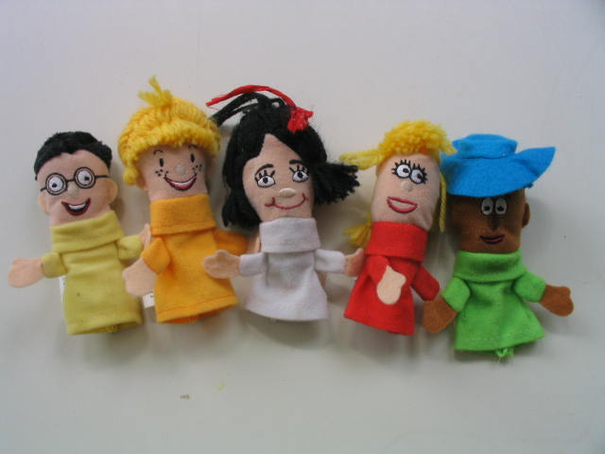

**Right to Left: Oscar Organisation, Ricky Resilience, Connie Confidence, Gabby Getalong and Pete Persistence.**

**Sun Safety**

To ensure that the children are protected from the harmful effects of the sun, we ask that all children bring a **named** hat which is either a Legionnaire or wide brimmed style that protects their face neck and ears, each day. Hats with a front peak only (Baseball caps) are not an acceptable means of protection for the neck and ears.

**Please note: hats with ties are a safety hazard – please remove any toggles / ties from your child’s hat.**

Navy Blue Legionnaire Hats are available for purchase @ $4.00 each.

**Sunscreen** will be reapplied through the day in line with the current Cancer Council recommendations.

We use sensitive sunscreen supplied by the Cancer Council.

(If your child has a medical need for a particular brand of sunscreen (eg- allergic to others) **we need a letter detailing exactly what sunscreen your child needs from your Doctor** and you will need to supply this sunscreen.

If you do not want your child to receive any sunscreen- please put your request in writing and it will be filed with your child’s personal documentation.

Please do not send children with exposed shoulders/ backs. These children will be asked to put on a t-shirt or will be required to spend all day inside as sunscreen alone is not an acceptable means of protection for these body parts during the hot summer months.

## **ADMINISTRATION OF MEDICATION**

We are committed to providing and maintaining a safe and healthy environment for staff, children, families, volunteers and visitors. This is achieved through an effective approach to the management of Workplace Health and Safety which includes the administration of medication to children.

Staff at the centre will assist with children’s medication if:

* The parent has completed and signed the sites ‘Request to Administer Medication’ paperwork;
* The child’s medical practitioner has completed the necessary sections in the sites ‘Request to Administer Medication’ paperwork;
* The medication is prescribed by a doctor and has the original label detailing the child’s name, required dosage and storage requirements.
* Medication should not be left in a child’s bag. It should be given directly to the staff member and stored in the first aid cabinet or fridge.
* Non prescription medication eg Paracetamol, Demazin etc. will not be administered by staff, unless supported by a written medication plan authorised by a Doctor and also written on their surgery letterhead.

**Immunisation**

To maintain your child’s ongoing enrolment and access to the Child Care Subsidy, it is essential that families provide us with ***UPDATED*** ***immunisation history statements***

The Australian Immunisation Register (AIR) is a national register that records vaccines and Immunisation History Statements can be accessed in the following ways:

* Online through MyGov
* Medicare Express Plus App – once a MyGov account has been created.
* Over the phone by calling AIR 1800 653 809

**Health Checks**

As part of a range of services to children and families in SA, the Government provides funding to Child and Youth Health to offer free health assessments for Preschool children.

The assessment includes vision; hearing; height and weight; dental health; general discussions with parents on health issues (eg. Immunisation) and questions on children’s growth and development.

A CYH Nurse will provide assessments at KFCC on

**Friday 17 February 2023.**



If your child is 4 years and 3 months or older, please collect a consent form from our front office. ***Bookings essential.***

**A parent or caregiver must accompany children to the Health Check.**

**Allied Health in Children’s Centres**

In 2023 our Centre will continue to participate in the Allied Health in Children’s Centres program. This program provides a Speech Pathologist – Louise O’Reilly and an Occupational Therapist – Sarah Harry one and a half days / week.

Speech Pathology and Occupational Therapy have been identified as having key roles in providing early intervention services to promote optimal child development outcomes and complement the role of Teachers and Educators employed across our Children’s Centre’s.

Next time you visit the Children's Centre, we invite you to take the time to visit our new, revamped, **Community Resource Library**. You will find this to your left as you enter the front reception area.  Our resource library contains a range of books and resources related to parenting, child development and children's books to support their emotional development. Resources are free to borrow for families attending preschool, long day care and community programs at the centre. If there are any topics of information that you are looking for, please let us know, as this will help us continue to grow our collection of resources.

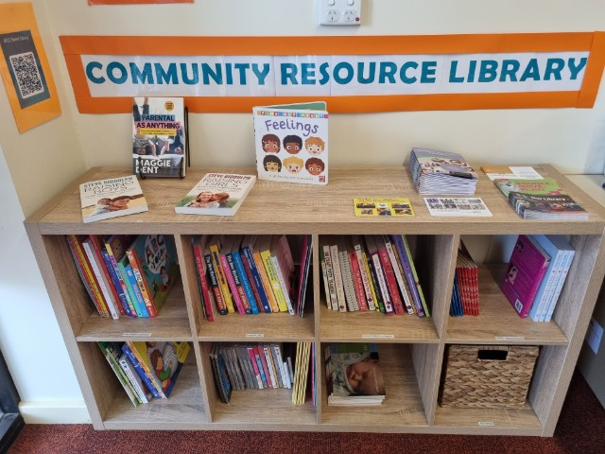

**Children’s Centre Governance**

At Keithcot Farm Children’s Centre we have 2 Constitutions and two Governing Councils, one for Preschool, Allied Health and Community Development Programs and the other for our Long Day Care program.

Membership of the Governing Council consists of parents elected at the Annual General Meeting in December and the staff leadership team. We still have several vacancies on both Governing Councils and would be delighted if you could nominate for one or both.

Educators and staff in partnership with the 2 Governing Councils

* Identify strategic priorities annually within a Preschool Quality Improvement Plan (PQIP).
* Work collaboratively to strengthen community partnerships
* Use human resources flexibly, effectively and efficiently.
* Are accountable to the local community.

Throughout the year we will be reviewing and updating our Children’s Centre Policies.

Our first meeting for 2023 is scheduled for Monday 13 February @ 6pm.

This first meeting will be a Face to Face here at the Children’s Centre, however ongoing meetings will be using an online platform and will start at 7pm.

We will review our National Quality Standards (NQS) policies and procedures relating to -

Quality Area 1: Educational Program & Practices and

Quality Area 5: Relationships with Children.

* Supervision Policy
* Interactions with Children
* Inclusive Practices
* Curriculum Planning
* Transitions for Children
* Children and Multi-media
* Water safety
* Excursions
* Environment

**Customer Feedback Policy**

We all expect quality and expert care and teaching for children in order that they achieve their potential.

We also recognise that at times things may go wrong.

If you have a concern or a complaint, we want you to let us know.

It’s important to learn from mistakes or misunderstandings so that we can improve your child’s experience and learning, and also improve processes where possible.

Negative feedback may be made by a parent if they think that the Children’s Centre has, for example:

* done something wrong
* failed to do something it should have done
* acted unfairly or impolitely.

Your concern or complaint may be about:

* the type, level, or quality of services
* the behaviour and decisions of staff
* a policy, procedure or practice.

Sometimes a complaint is about something we have to do because of State or Federal law. In such cases we

are able to talk to you about the matter and help you understand the requirements and why they exist.

The first step in working through a complaint is to talk to your child’s Primary Educator. (If you do not know who this is – please ask Anne or Jen or give us a call on 82512700).

If you still are not satisfied then please refer the concern to

**Anne Whittleston:** **Director – Education and Care.**

**E:** [**Anne.whittleston916@schools.sa.edu.au**](mailto:Anne.whittleston916@schools.sa.edu.au)

**Children’s Personal Belongings**

****Please write your child's name on the inside of their shoes /sandals. This will make matching the right feet to the right shoes much easier!

**Please clearly write names on all belongings.**

Please check the **Lost Property Rack** for any items which may belong to your child.

All remaining items will be donated to charity at the end of each term.

|  |  |  |
| --- | --- | --- |
| **Car Park**   |  | | --- | | The Children’s Centre Car Park is available for families to access **before 8.15 am** and **after 3.30pm**. Please **do not** park in between these hours in the Children’s Centre or school carpark as they are for the Children’s Centre staff and people who have been issued with a Car Park pass. Please obey the signs, and do not leave your car unattended in the “Kiss and Drop Zones” during school drop off and pick up times. | | We have been informed by the South Australian Police Department (SAPOL) that at the beginning of each school term all available police patrols will be dispatched to all schools, preschools, and Children’s Centres with the focus on the enforcement of speed limits, parking infringements and dangerous driving.  They may also be drug and alcohol testing drivers. The Tea Tree Gully Council will also be active with parking inspectors supporting the SAPOL initiative.  If you witness a driver breaking the road rules around our Children’s Centre, SAPOL are encouraging families and staff to record the vehicle registration number and report it to **131 444.**  The Police will talk to and possibly fine these irresponsible people. | |