

**July Newsletter**



**Jen’s Retirement**

On Friday 7 July we will bid a fond farewell to our dear friend and colleague – Jen Reid.

Jen was initially employed by the Department for Education in 1995 where she ran the Occasional Care Program at the then Keithcot Farm Kindergarten.

In 2007, Jen won the Assistant Director position when the Centre became a Children’s Centre with Long Day Care. Not only has Jen been a strong advocate for children and families at Keithcot Farm, but she has also been an active member of the Community Children’s Centres of South Australia (CCCSA) and a strong voice on the Children’s Week Committee. Jen’s amazing husband Chuck also deserves a mention as he has repaired countless toys, puzzles, and other essential equipment over the last 25 years!

We are going to miss Jen enormously, however we know that she and Chuck deserve to enjoy many years of travel catching up with their daughter Jess and son Billy who are currently living overseas as well as other adventures on their bucket list!

Jodie Murray has accepted the role as Assistant Director. Jodie has worked across the Childcare and Preschool program since 2007 and has been our very diligent and capable Workplace Health and Safety Rep for several years. Over the last few weeks Jodie has been work shadowing Jen and we are confident that there will be a smooth transition as Jodie takes on this leadership role within our Centre.

**Special Person’s Week**

Many thanks for all family members and friends as well as our amazing staff team for making our Special Persons Week such a special occasion. We will have another Special Persons Week later in Term 3 – dates to be confirmed.

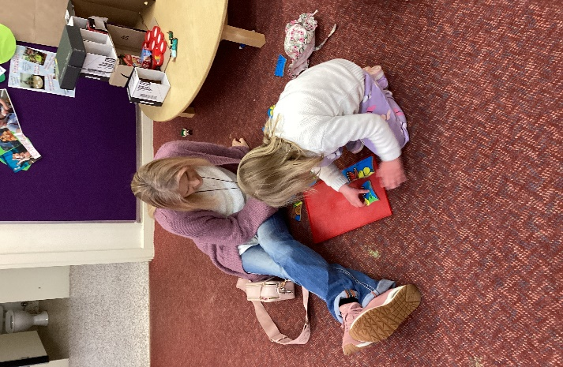

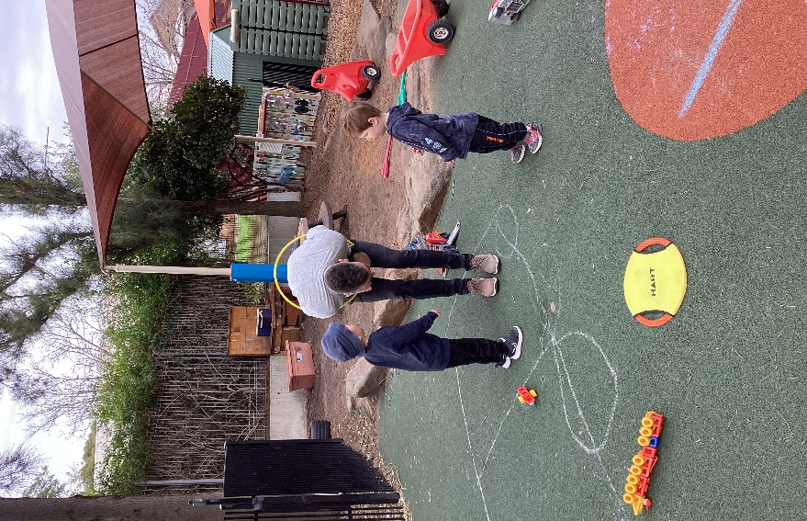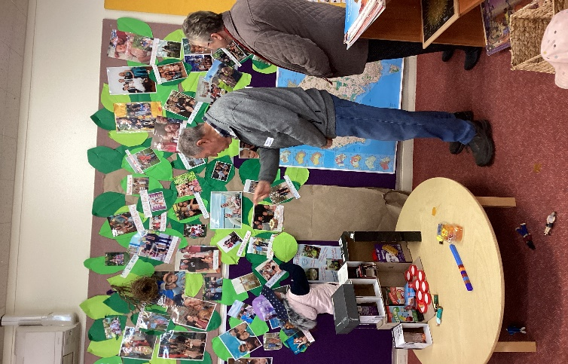



**Preschool: End of Term 2**

The last Preschool Day for Term 2 will be **Friday 7 July.** Preschool will resume on Monday 24 July.

Long Day Care will continue through the Pre School holidays. ***If you normally access Before and After Session Care during the term and need care in the holidays please let us know to ensure staff rosters are adjusted.***

**Reminder - End of Year Closure**

Governing Council approved to **close the whole Centre** from **12.30pm** on **Friday 15 December 2023**.

The Long Day Care program will then resume on

**Monday 8 January 2024.**

**2024 Preschool year will commence Monday 29 January.**

**2024 Preschool Program**

In August 2023 letters will be sent to families who have registered an Expression of Interest in our Preschool Program and who live in our immediate catchment area

* Bridge Road
* McIntyre Road
* The Golden Way
* The Grove Way

offering a place in our Preschool Program for 2024.

Depending on the number of available positions, offers for families who live beyond the catchment will be mailed out in November

The aim of this procedure is to ensure that children are offered a place in their local centre. A consistent state-wide approach, including the establishment of local catchment areas, ensures that all families are provided with the same information about their Preschool enrolment options.

**Community Development Update**

All updated Community Development program for term 3 will be on our Facebook page, website and emailed to Centre and local community distribution lists.

**Being with Baby**:

Facilitated by our Occupational Therapist, Sarah, recommences on Tuesday 8August.

**Being with Big Feelings**:

A series of 4 workshops focusing on supporting parents to better understand the emotional world of their children. Commencing Monday 31 July.

**Blended Therapy:**

Will continue to offer a NDIS funded support group on Thursday mornings.

**Allied Health Drop In and Chat:**

Our Speech Pathologist, Louise and Occupational Therapist, Sarah will continue to offer this service to support families who are looking for advice about their child’s development and wanting support to access relevant community services.

**Infant Massage:**

Recommences Friday 28 July.

**Learning Together Playgroup:**

Tuesday mornings – facilitated by United Care Wesley Bowden.

**My Time:**

This group is a facilitated peer support program for parents and cares of children with a disability, developmental delay or chronic medical condition.

My Time will run for the first time at Keithcot Farm Children’s Centre commencing Friday 4August from 12:30 until 2:30pm.

**Play in the park:**

We are going to trial some walk and talk sessions.

Moving forward the Tea Tree Gully Council are keen to support the Play in the Park program and are looking at providing a Physiotherapist as an extra professional to this service along with our Occupational Therapist, Speech Pathologist and Community Development Coordinator.

**Speak and Sing**:

Recommences Wednesday 26July

This program will again be offered later in Term 3.



**Please contact Nathan (CDC) for more information**

* **in person at the Centre**
* **by phone 0435 219 942**
* **Email:**[**Nathan.mcguinness3@sa.gov.au**](mailto:Nathan.mcguinness3@sa.gov.au)